Appendix 1

Site Location Plan

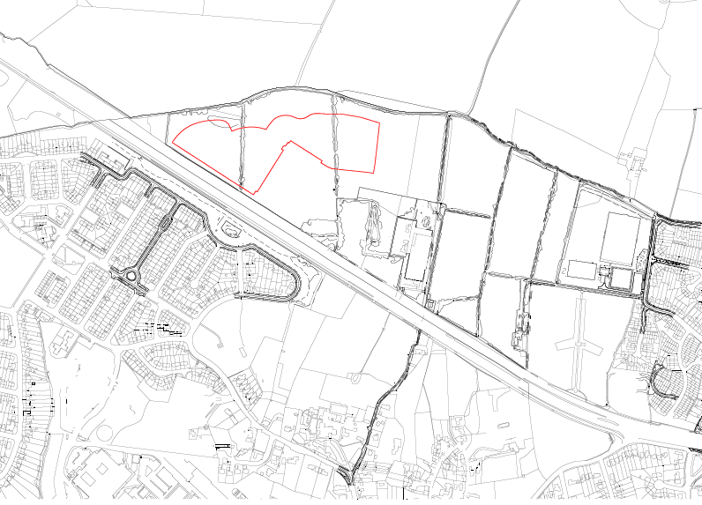





Appendix 2

Public Engagement

5.15 The first round of public consultation took place in May 2015 (Stage 1) and was focussed on the layout and key linkages of Phase 1 following design development with the City Council and the Oxford Design Review Panel. A further round of consultation was carried out in July 2015, based on a revised layout for the Phase 1 site and focussed more heavily on the house types and the range of dwellings that comprise the Proposed Development.

5.16 Publicity for the exhibitions included posters on the site notice board on Barton Village Road, at the Barton Neighbourhood Centre and the Northway Community Centre. Working with the Barton Community Association, leaflets were delivered to over 2,600 residents on the Barton and Northway estates, notifying them of the forthcoming events and explaining their purpose. The content of the exhibitions were also presented to the Barton Integration and Community Engagement Partnership (BICEP) prior to the events. The exhibitions consisted of a series of boards together with questionnaires allowing visitors to address questions and make general comments on the proposals.

*Stage 1: Barton Neighbourhood Centre (16th May) & Northway Community Centre (19th May)*

5.17 Stage 1 of the engagement focussed on the distinctive areas of the Phase 1 masterplan layout and the range of homes and apartments that reflect the varying densities of Phase 1 as established at outline stage.

5.18 These events were well attended with 40-50 residents at the Barton event and in the order of 20 residents at the Northway event. The DAS provides additional information, but key messages from the events were follows:

▪ Support for mix of house types and proportion of affordable homes (not built to a ‘lower’ standard);

▪ Concern over long-term integration between private and social housing;

▪ Focus on sustainability in design of homes a positive;

▪ More information on traffic and access would be helpful;

▪ Local infrastructure needs major investment to cope with extra traffic;

▪ Strong support for emerging home designs, although some felt the design is too modern;

▪ Consideration should be given to flood risk and delivering the school as soon as possible;

▪ Green spaces well thought out;

▪ Clearer floorplans would be helpful at the next exhibition.

▪ Generally supportive of the need for new homes in Oxford and for Barton Park proposals;

▪ Concern regarding the access junction from the A40 and resultant harm to Northway through increased traffic and noise and resultant safety issues – how will cars and taxis be prevented from using route through Northway;

▪ Keen to see an alternative access solution that will not divert traffic through Northway;

▪ Would like to be kept informed of details regarding the proposed bus route;

▪ Re-assurances that the proposals will not exacerbate flooding, particularly in Marston;

▪ Loss of trees a significant concern.

5.19 The design development response following the first round of consultation was focussed on:

▪ Enhancing permeability;

▪ Ensuring the proposed green space (Gladstone Gardens) worked for residents and was inviting and would be well used and not dominated by cars at its edges but will need to be managed;

▪ House type and apartment design development;

▪ Further work on the raised community space within the podium block fronting the A40 including improvements to ensure that this is well used and instils a sense of ownership;

▪ Additional information on the sustainability principles at the heart of the home design.

*Stage 2: Barton Neighbourhood Centre (18th July) & Northway Community Centre (15th July)*

5.20 Each event was supported by a set of exhibition boards showing the proposals for the house and apartment types that had responded to design development and the Oxford Design Review Panel workshops. Examples of these boards are set out in the DAS accompanying the RMA.

5.21 Attendance at both events was encouraging with around 50 attendees at the Barton event which took place as part of the Barton Summer Spectacular on the day. For Northway there were in the order of 25 attendees.

5.22 The second round of engagement prompted greater interest in owning or the position in relation to social housing. Both events provided a range of views but those at Northway were focussed on their concern over the safety of children playing near the new A40 junction at Northway. At Barton, the Proposed Development attracted a very positive response with key messages including:

▪ Praise for family friendly housing and the modern clean look to the architecture;

▪ People were interested to know the measures taken to sound proof the apartments;

▪ Pleased to see the green space at the heart of the scheme and the links to the linear park.

Appendix 3

Oxford Design Review Panel Responses

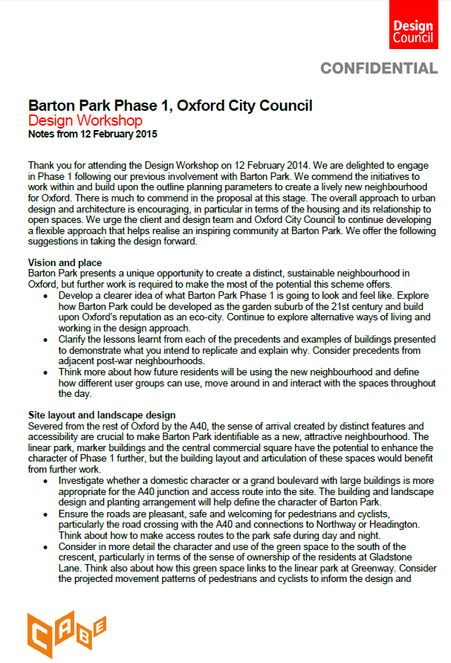

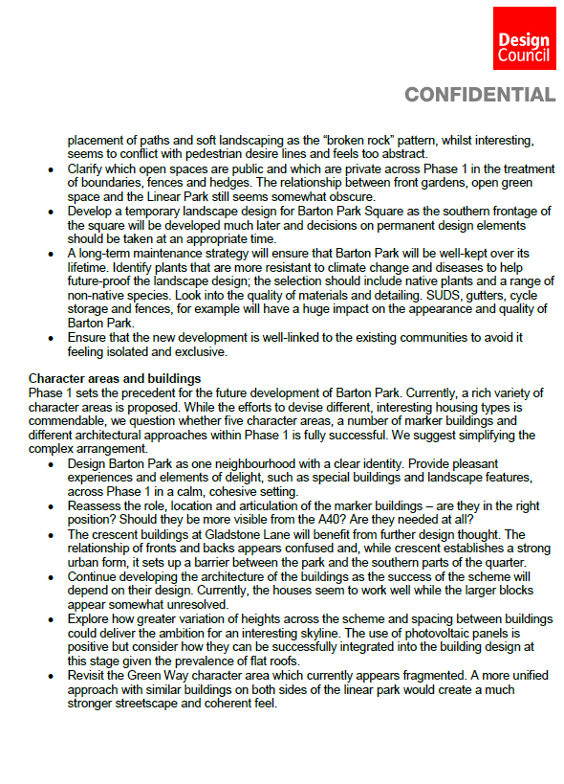

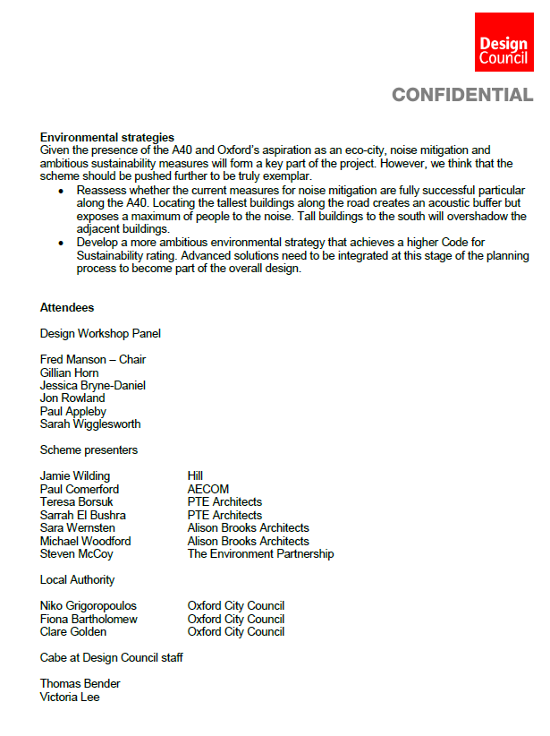

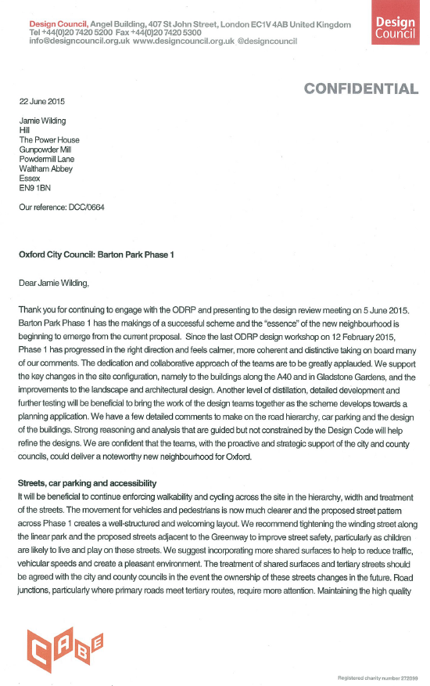

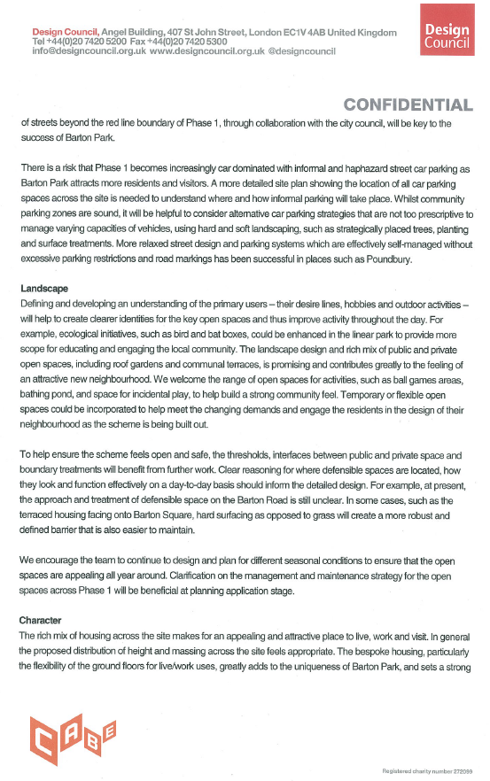

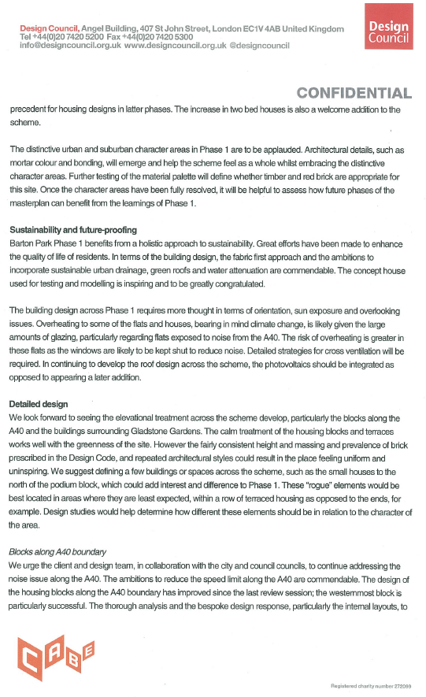

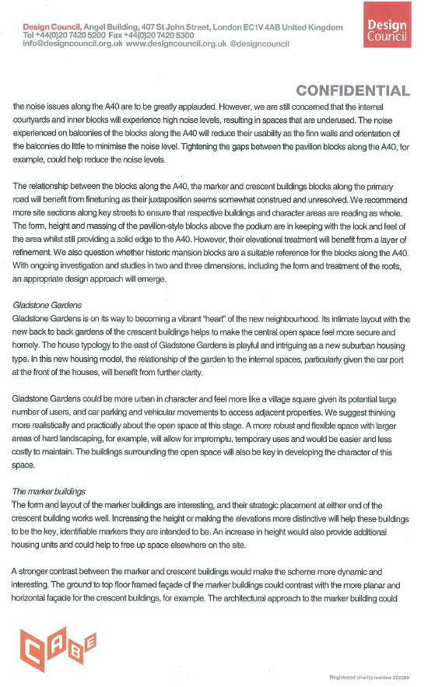

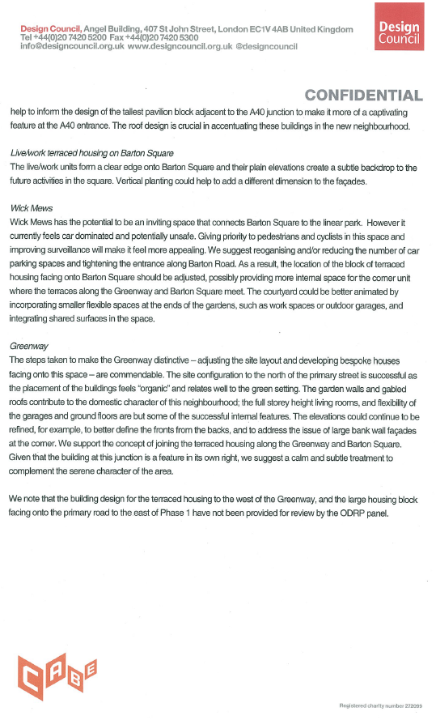

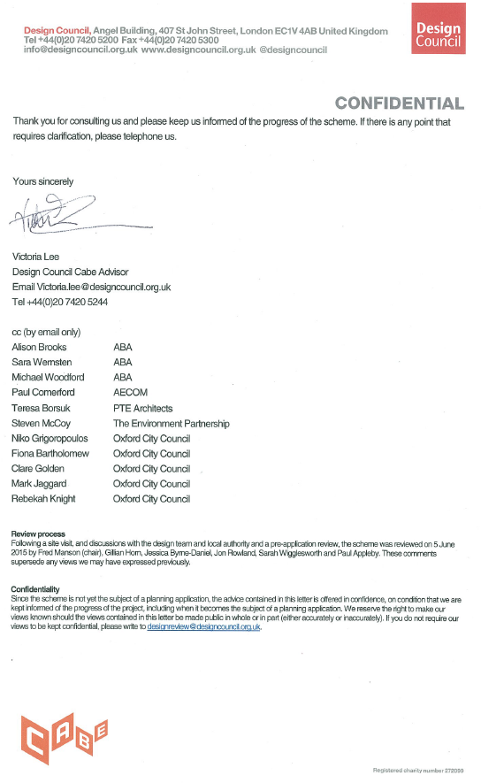

Applicants comments on the ODRP

The proposals for Barton Park Phase 1 were presented to the Oxford Design Review Panel on two occasions; on 12 February and 5 June 2015. The Oxford Design Review Panel is run as a partnership by Oxford City Council with Design Council Cabe.

The first presentation focussed on how the masterplan had been developed from the outline proposals and development of the character areas and typologies. The Panel commended the overall approach to urban design and architecture, particularly in terms of the housing and its relationship to open space. One of the Panel’s key suggestions was to consider simplifying the masterplan by reducing the number of marker buildings and typologies to create a more unified neighbourhood. Additional comments were

A40 living accommodation - no bedrooms facing the A40

Reduce the number of marker buildings

Simplify the street frontages

Rationalise the connections and routes

Simplify the access to the rear of the primary street

crescent - Omit the parking mews.

These suggestions were taken on board by the design team in developing the proposals. At the second presentation to the Panel on 5 June 2015 the further development of the scheme was well received and the panel commented that “Phase 1 has progressed in the right direction and feels calmer, more coherent and distinctive.” The panel commended the rich mix of housing across the site and the distinctive character areas and made some further suggestions, primarily on streets and landscape, which have been integrated into the final proposals.

The panel applauded the distinctive urban and suburban character areas within Phase 1

Appendix 4

Northway Residents Group Comments



**RESIDENTSAGAINST THE BUS LINK**

Nicholas Fell

14 Ash Grove, Headington

Oxford

OX3 9JL

Saturday 23rd January 2016

Oxford City Council

St Aldates Chambers

113 St Aldates

Oxford OX1

Dear Sir / Madam, to whom it may concern,

I am writing in my capacity of Independent Consultant, on behalf of Northway Residents Group, in order to reply to the consultation notice, that went up on the contractors security fencing, at Foxwell Drive, and I told Theo Smith, that I wished to make representations regarding the contents of the said notice, signed by Mr Edwards, and I am now writing to you to make that very representation. I have studied the contents of the attachment, that Theo Smith sent me, with his e mail, and I have gone through the list of policies, and picked out those that I think, and believe to be most relevant to the situation, and about which I wish to make, and pass comment on, as grounds upon which I wish to rely for my defence, and which I wish to have taken into consideration.

I would contest and object to the grant of outline planning permission, for the following reasons.

I wish to contest the contents of Parameter Plan 2, 3 and 4, with 4 being movement and access, which Northway Residents Group find completely, and totally unacceptable, and most objectionable. Let me make one thing clear, you are NOT coming across Foxwell Drive, under any circumstances whatever, you have another route for access, I would recommend that you go away and use it. The link road is a violation of road safety practise, and will put children's lives at risk, which is the very reason the fence was erected in 1952, in the first place, to prevent children being able to gain access to the Northern Bypass.

Also at page 58, part two, in the attachment that Theo Smith sent me, it shows intent to take Buses up Meaden Hill, and again shown at page 60, under block edge constraints and opportunities. Also no Statutory Transport Assessment has been carried out at Foxwell Drive, under Policy BA5, and see Policy BA6 Access, as well, Link Road issues. Connected issues are Policies TR1 Transport Assessment under the Oxford Local Plan, and Policy TR7 Bus Service and Bus Priority, under the Oxford Local Plan, to which I wish to raise objection.

Also the Link Road falls foul of your own policy CS14 supporting city wide movement, as Foxwell Drive Link Road is not necessary, that was proven at our Town Green Public Enquiry, as you have another route available to you, and you said with or without, the link road, Barton Park goes ahead. You are in material breach of policy CS13 Access.

Your documents say that Access construction “enabling works” supposedly does not need planning permission, and that it is somehow excluded, well I would like to beg to differ on that one, I would contend that it does indeed need planning permission, the way that I read, and interpret the law.

You cannot legally come across at Foxwell Drive, as you have no legal statutory power over Foxwell Drive, therefore you cannot legally act. You have never shown us the original appropriation document for Foxwell Drive, nor have you shown us an original ministerial consent document from 1952/53. Show us the documents, lets see the evidence, show us the proof. The fact that to date so far, that you have not done so, is a breach of section 64, of the Law of Property Act 1925, production and safe custody of documents.

Plus Oxford Preservation Trust, in partnership with the Crown Estate, jointly own the central reservation of the Northern Bypass, and the trees on it, and have done since 1936.

In 2011 Steve Sprason committed an unlawful unilateral act, as a landlord cannot, by his own unilateral act, deprive his tenant of the benefit of an interest in land appurtenant to the property comprised in the tenancy. A tenants rights do not rest merely in contract law, they also give him an interest in land. Law says that land let together with a dwelling house shall be treated as part of the dwelling house, unless the land is agricultural land exceeding two acres. Because of the split site issue at Foxwell Drive, that Henry Berry's covenanted land, marked pink on the land registry map, that starts at the top of Dunstan Park, and goes down as far as John Buchan Road, where it cuts off, and another covenant picks up, I hereby call witnesses from Corpus Christi College Oxford in our defence. I also rely upon the terms of the J A Pye restrictive covenant. I would also like to call Councillor Mary Clarkson in my defence, and I wish to call witnesses from Borrowmead Road, over the matter of their leases.

Steve Sprason committed breaches of section 122, and section 123 of the local government act 1972, and he likewise also breached section 163 of the local government act 1933.

In that he was supposed to consider the need for public open space within the locality of Northway. The land is expressly made subject to the rights of other persons, meanng the residents, in respect of the land concerned. The council must consider the public need within the locality for the existing need/use as was ruled to be the case in dowty boulton paul Ltd versus Wolverhampton Corporation.

I should also point out, that your wish or desire for a fifty mile per hour speed limit is still unworkable, as Thames Valley Police are still not on board over it, and have said they have neither the manpower, or the time to enforce it, and they have said that the fifty mile per hour speed limit is arbitrary, unsuitable, and inappropriate, due to the sort of terrain the bypass runs through, that drivers would not obey it, and would not relate fifty miles per hour to the area setting it passes through. Any ticket challenge in a court of law would succeed.

Houses in Northway, along Saxon Way are already suffering unacceptable levels of seismic vibration, and subsidence damage, caused by Oxford Bus Company buses, the roads in both Saxon Way and Halliday Hill, roads that were never built to take the punishment of heavy bus axles, are cracking up under the strain. I also wish to raise further grounds of objection under your own Oxford Local Plan policy CP13 Accessibility. The Saxon Way Bus entrance into the John Radcliffe, is equally unacceptable, under the Environment Protection Act sections 79, and 80. On grounds of public and private nuisance. Buses are known to be thirteen times more likely to knock down a pedestrian than white van man.

That is taken from a Safe Speed publication, titled Buses Are Surprisingly Dangerous To Pedestrians, and this is backed up by irrefutable proof, from the Alliance of British Drivers press release, number 432, titled Government Pedestrian Casualty Figures Overturn Public Perception On Speed and Bus Safety.

On the issue of safety, Grosvenors, the developers told Jane Cox, the Chairman of Northway Residents Group, that putting up a barrier to the link road was not possible, Oxford Mail article Northways treasured gren, peace and safety is about to be sacrificed, Thursday, September 26th 2013, and local city councillor, Roy Darke, for Northway and Headington Hill Ward, is quoted as having said that unless extra safety measures were installed, local children were at risk of being splattered. And Michael Crofton Briggs is quoted as having said, that children would have to jump out of the way.

Another reason we object to the Link Road is because you say, in one of your own documents, quoted in part of Theo Smiths attachment to the e mail he sent me, which I now quote “the effect of reflected noise incident upon dwellings at Foxwell Drive, across the highway, from the proposed development should therefore be considered. See your own policy CP21 Noise Oxford Local Plan, and also I wish to make further objection under policy CP8, designing development to meet its functional need, as the Barton Park development does not, repeat does not, respect Northway context.

You have admitted yourselves that, noise attenuation measures are required by condition to this permission, which you are blatantly breaking and flouting.

The High rise lantern buildings would act as a noise mirror, they are too close to Foxwell Drive, they will unacceptably overshadow, and overlook, I want them moved further away from Foxwell Drive, or removed, and dropped from the plan altogether, so as to mitigate noise reflection, I will accept nothing less, and this is non negotiable. A good example of the effects of a noise mirror, is the amount of noise that residents have to put up with, that gets reflected off the walls of the John Radcliffe Hospital buildings, made by the rotors of the flying doctor helicopter, when it is on the landing pad, is bad enough.

The proposed lantern buildings are out of scale, and out of keeping with the surrounding area, they don't fit in with surrounding buildings, they will overly dominate, and from the drawings of their appearance, they are something that would have been fit for a late nineteen fifties, early sixties housing estate, they are ugly and remind me of soviet blocks in Moscow. They are completely inappropriate, and they are too tall. Have you learnt nothing from Port Meadow?

The developers noise mitigation report as it currently stands is inadequate, and unacceptable, no noise monitoring has been done in Northway, only done or carried out to date in Barton.

This will further unacceptably raise the decibel count, which has been made unlivable since the trees were unlawfully cut down on Foxwell Drive, in contravention of the Nesting Bird Season, that runs from 1st March to 31st August, which was also a breach of the Hedgerow Regulations 1997. Although sometimes it stretches past this date, and sometimes it begins before 1st March in some circumstances, depending on what birds are nesting.

This was a breach of the 1954 protection of birds act, and it was also a breach of the 1981 countryside and wildlife act.

The Barton Northway Link Road scheme will unacceptably impact on amenity of people living nearby, thereby planning policy statement 8 has been breached. Also I should mention that ENV 3.3 states clearly that: creating and managing green spaces in cities, towns and villages to serve multiple purposes, and contribute to distinctive local character has likewise been breached. Also likewise ENV 6.4 has been breached, that states encouraging the protection of, and enhancement of, open spaces and playing fields, which is what our whole opposition to the link road has been about, for the long term benefit of the whole community, has been clearly breached by the council, and Barton Oxford LLP, and Blackwell Construction. Also the council is in clear material violation of policy LC1, that talks about protecting local character, environmental quality and residential amenity, which is what we have been trying to protect with our campaign against the link road.

Plus the council are in defiance of the addendum to PPS7, Planning Policy Statement 7, that talks about safeguarding the character of established residential areas.

Also taken from the list of policies that Theo Smith sent me, as part of the attachment, is grassland mitigation, which at Foxwell Drive, this has not been complied with, under Oxford Local Plan.

Also Foxwell Drive falls within policy BA2 Recreation Ground, and for another thing, you are legally locked into SR2/SR5 designation on Foxwell Drive until December 2016, when it comes up for review, and which you cannot escape from your responsibilities under. You are also in breach of Policy OS1 protection of open space.

You are also in breach of the Green Space Strategy document 2012 to 2026, aim 1, 2, 3, 4, 5, and 6 has been breached. The council are in violation of background paper D3 Green Spaces, Sports and Leisure, plus the Council are in clear violation of policy PPG17.

As Northway is under provided with green space, to the tune of 17.5 hectares, which you recognise yourselves, under your own Green Space Strategy document, and which was mentioned by Mr Mark Pett, in his own document, the Council Green Space Grab, the headington green space catastrophe. You are in violation of Policy CS1 as more, and extra deficiency, on top of what already exists, in the area will be caused.

You are also in defiance of your own HP13 policy, using up our important outdoor space. The council have failed to, and cannot provide us with, alternative green space provision.

You are in breach of your own outdoor recreation community facilities policies, under points 11.2.4, and 11.2.5, you are also violating your green belt policy NE2, and Foxwell Drive, should strictly, fall under Safeguarded Land, Policy NE3, due to the comments in 1959, by Councillor Renshaw. Foxwell Drive also falls under Policy HE8 important parks and gardens.

Section 193 of the law of Property Act 1925 gives members of the public rights of access for air and exercise to certain common land, on manorial waste or commons.

The link road would obstruct access to Foxwell Drive, residents of Borrowmead Road have tenancy rights of access, and rights of common to Foxwell Drive under section 62 of the Law of Property Act 1925, and section 6 of the 1881 Conveyancing Act. The residents of Borrowmead Road under their schedule of leases impliedly granted them trustees rights of common to Foxwell Drive. Thereby, the council are impeding unlawfully the residents access to the land by means of the Barton Northway Link Road Scheme. The council is obstructing the residents rights as commoners. The residents thereby have a right to an action against the Council, for nuisance both public and private, for disturbance of their rights.

Conveyancing Act 1881, section 6, sub sections 1&3, also incorporated into section 62, law of property act 1925, it is clear that a right to require the owner of adjoining land, to keep the boundary fence in repair, is a right which the law will recognise as a quasi easement, and clearly the council, and blackwell construction are now in violation of this rule, as they are not keeping the boundary fence in repair.

And the Local Government Act of 1933 section 163 part 7 says, and I quote “the appropriation of land by a local authority shall be subject to any covenant or restriction affecting the use of the land in their hands”. This is the case at Foxwell Drive, from information from the Land Registry Title document.

The Council are in legal defiance of, the J A Pye restrictive covenant, and are in defiance of the Henry Berry Covenant, as well. And in defiance of the terms of the Annex to the Henry Berry covenant, under which residents of the streets coming off Foxwell Drive have rights of common, and rights of access, and each and every one of them have to be asked for their consent to the works being carried out by Blackwell Construction, which are currently unlawful and are illegal.

The Barton Northway Link Road scheme falls foul of the comments made, by Paul Sempel, in the Headington And Marston Area Transport Strategy document, in the year 2000, when the council was told by the Department Of Transport, that no further link roads would be allowed to be built, between Green Road Roundabout, and the Marsh Lane/Cherwell Drive off slip junction on the Northern Bypass. It was also turned down in 1994 for the same reason, due to the Northern Bypass bad accident statistics.

Colin Buchanan and Partners considers that the councils are correct in rejecting the A40 Northern Bypass Link Road, as an option for the local transport strategy. This was decided on the basis that it would have a significant physical impact on adjacent property, meaning Foxwell Drive, and on the wider area (meaning Northway more widely) it would also have a detrimental impact on the operation of the ring road, which it is the county councils Oxfordshire highways policy to protect, and that the costs could not be justified, even by the small to non existent benefits delivered.

Also the local John Radcliffe Hospital trust has been quoted on the record, as having said that: there is no desire on its part to see this link introduced, and they have also said categorically and unambiguously that: a direct road link from the A40 Northern Bypass will not be required

So therefore, I question what the councils real motive is, for the Barton Northway Link Road, therefore there is no need to throw it open to Ambulances, if what the hospital said is true.

Also the Link Road is unlawful under your own NE21 policy, on wildlife corridors, and Foxwell Drive is a wildlife corridor between Dunstan Park and the back of the Court Place Farm, OXSRAD site, by way of the land that forms part of the Court Place Farm Nature Park, that runs through behind the borrowmead road flats, and putting flood water on this piece of land would be an unlawful risk to public health, and for another thing, nature parks are supposed to be protected in law, and is a legal non starter. The residents of Northway will lay legal challenge to this idea, and this would run counter to policy NE23, and would destroy our Northway habitat.

Foxwell Drive is a continuation of both Ruskin Fields, and Dunstan Park, both of which are in the grade 4 conservation area, and it is inconsistent that Foxwell Drive is not also in the conservation area, and should be included, and should be made so, this falls within policy HE7.

The Link Road is in violation of the case of Attorney General versus Poole Corporation, it is said that the section (section 10 open spaces act) imposes on a local authority which has acquired an open space, an obligation to keep that open space as an open space, in this sense that nothing must be done with regard to any portion of it, which would prevent the public from freely having access to such portion, the workmen of Blackwell Construction are in defiance of this. The council are violating the 1863 Town Gardens Protection Act, Section 2 protection of open spaces from encroachments.

In the same way the council are in material violation of section 29 the commons act 1876, and section 12 the inclosure act 1857, they are also breaking the law of inclosure act 1845.

On the second of April 2015, I had the following e mail, from the now, late deceased John Thompson, from Forest of Oxford, here is what he said to me: Further to our recent discussion, I would like to confirm the Forest of Oxfords opposition to the removal of the trees adjacent to the bypass (at Foxwell Drive). They form an important screen, as well as providing a vital wildlife corridor. Since Jane Cox approached FOX, this has been an important tree planting project, and was undertaken with the support of local residents and the Oxfordshire Conservation Volunteers. This is a highly significant community project, and it is disgraceful that the city council are destroying this valuable local amenity, especially as the council provided funding for the trees under its environmental improvement programme.

John Thompson, Secretary, Forest of Oxford.

And Oxford Preservation Trust also owns the trees along the central reservation, of the Oxford Northern Bypass, and they have done since 1936, in partnership with the crown estate.The trees were planted to celebrate the jubilee of King George, and were to all intents and purposes under TPO conditions. The hedgerows also helped to guard high sided heavy goods vehicle truck trailer rigs from cross winds blowing across the carriageways, and the hedgerows helped prevent a build up of of turbulence. The trees helped to lower the noise decibel count by around 6 to 10 decibels, serving to soften, mute, muffle and attenuate the traffic noise from all classes of traffic passing along the Northern Bypass, in both directions. The hedgerows also protected residents from high wattage glare, from trucks headlights and spot lamps, especially those fitted with xenon bulbs, this is particularly bad on rainy wet winter nights, when dazzle can be a real problem.

The trees and bushes on Foxwell Drive are an important, and very effective environmental noise suppression barrier, and they also act to screen out light pollution from passing traffic at night, they also perform a very important job, of locking up airborne particulate pollution from vehicle exhaust.

The Barton Northway Link Road Scheme is unacceptable on grounds that it would lead to an increase in surface water run off, extra pressure on roadside storm drains/drain pot gullies, and would raise the accident risk to young children to an unacceptably high level. To prove my point, in February 2013, local labour councillor, Mary Clarkson, of Lower Farm, Old Headington, was knocked off her bicycle, at the JR Hospital bus access road entrance on Saxon Way. It would also lead to an unacceptable increase in noise pollution, and fume pollution, and an unacceptable increase in overall traffic volume in what was becoming quite a desirable area of Headington. It would lead to an unacceptable deterioration in the quality of life for local residents. Houses in Northway are already being structurally damaged by seismic vibration, and subsidence caused by the heavy axles of Oxford Bus Company double decker buses. Cracks and booms are heard every time a bus passes up and down Saxon Way. Residents are having to move into back bedrooms upstairs, to get away from the anti social engine noise, and exhaust fume pollution being caused by Oxford Bus Company buses. Both Saxon Way, and Halliday Hill are cracking up under the intolerable strain, that they are currently being placed under. The roads of Northway Estate were never intended, and were never built to withstand the constant repeated pounding by heavy bus tyres.

The Barton Northway Link Road is contrary to policy NE15/NE16 loss of trees and hedgerows, loss of these has caused significant harm, and detrimental impact on public amenity and ecological interest, and the fact that the council has failed in its statutory duty, to carry out a legally required Environmental Impact Assessment on Northway. Trees and Hedgerows come under Natural Environment in the Oxford Local Plan, at section 4.7.1 through section 4.7.4.

In the 2013 to 2027 green space strategy document it mentions at point 5.13 Oxfords trees are of immense environmental and aesthetic value, trees play a key role in defining the landscape of a green space, such as Foxwell Drive for instance. They also provide a vital habitat for wildlife. Oxford City Council recognises these benefits, and seeks to preserve healthy trees, then acts like a complete hypocrite at Foxwell Drive, and cuts down healthy trees in direct contradiction, and violation of policy.

The overall aim of the tree policy is to ensure that Oxfords tree stock is retained, enhanced and increased, but not at Foxwell Drive in Northway, where they hypocritically cut them down.

The other problem for Steve Sprason is, that the land may very well have been amenity land, rather than open space land, which is provable due to the 1959 Renshaw Question, and also there is the problem that in 1955, a Mr Rose according to the council committee minute books of the time, was using Foxwell Drive, in partnership with Mr Henry Berry, from Lower Farm, as an orchard (fruit and timber) and for grazing cattle purposes, under the 1948 Agricultural Holdings Act.

According to my research, amenity land, generally speaking, refers to land that provides “scenic value” to the built environment, which is exactly what Councillor Renshaw was getting at with his question to council in 1959. The law states clearly and unambiguously that , there is very little you can do with amenity land in the long term, other than grazing animals or planting trees, which my friends Jane Cox from Meaden Hill, and John Thompson, from Forest of Oxford did in the early 1980s, when Jane won a load of trees in an environmental competition, which were planted for ecological reasons on Foxwell Drive.

Amenity land comes with various restrictions on its usage for building on, and which is supposed to provide a green space in between developments or belts of built on land. Which again comes back to the Renshaw question of 1959. Had the council actually appropriated the land in 1952, then councillor Renshaw would not have had any reason to ask the question that he did.

With reference to the question asked by councillor renshaw, at the meeting of council, on 2nd February 1959, council is informed that as the Northway (Foxwell Drive) open space, provides lovely views of Elsfield, and the surrounding country, and is also somewhere quiet where the public can go to rest and picnic (town green compatible) the committee prefers it to be left in its natural state (in other words agricultural farmland) (Henry Berry had been using the land up to 1957 to walk cattle on). That skewers once and for all, the council argument they laid the land out, as an open space. In fact Curtins Consulting Geo Environmental report for the Dora Carr Close development, says that the land in the area, and vicinity since 1950 has been open farmland.

Taking down the metal railing road safety fence was unlawful, and was a breach of procedural legitimate expectation, which the council failed to notify, and failed to advertise, and failed to consult on it as they legally should have done, and were legally obliged to do.

We could have prevented the council from taking down the fence, using section 194 of the law of property act 1925, where it says or unless the erection of fences will help to prevent accidents, and where it says that the secretary of state (SoS) has to take into account the benefits to the neighbourhood.

The road safety fence was to Department standard TD19/85 ref 6, the metal road safety railing fence was to protect from vehicle impacts, and what is called errant vehicle strikes, if a driver loses control of their car, and leaves the road. The effectiveness of guard railing is lessened if gaps are left open in it, or what are called category 1 defects. Of which there are several examples along Foxwell Drive. The last mandatory road safety audit was done in August 2005 by Oxfordshire County Council. The issue of the fence is also tied into the 1948 Henry Berry covenant , that the council signed up to, and made themselves a party to.

Extract taken from city of oxford council minutes and reports of committees, dated 1951 to 1952, paragraph 1699, page 723, which reads as follows: Children are endangered by reason of the fact that they can obtain access from the Northway Estate onto the Northern Bypass, through a hedge, which runs along the front of the estate. Subject to the approval of the finance committee, the city architect has been authorised to arrange for the hedge to be topped, and to provide chesnut fencing on the inner side there, at an estimated cost of £150. The committee concurs. It was also recorded in the same city of oxford minutes, and reports of committees that: The committee had been advised that it was too late in the season to top the hedge, running along the front of Northway Estate, referred to in paragraph 1699 (2) but the proposal to provide chesnut fencing on the inner side of the hedge, will proceed.

This is confirmed by old photographs we have seen. The fencing was later replaced by more permanent metal railing fence, erected behind the tree line, where it stands to this day.

The road safety fence created a promisor/promisee relationship, that is more or less of a contractual nature in law, the intent is clear, and unambiguous, as it is set down in writing in the council committee minute books. The fence thereby gives the residents of Northway a legal benefit from it, thereby giving the residents legal interest, and thereby making the residents a party to it, third party they maybe , unnamed third parties at that, not originally listed, or mentioned in the covenant. The residents have been provided with, or derive a benefit under, or from, the fence having been erected, therefore the residents have a legal right to enforce that interest, the interest being that the fence was erected on grounds of road safety in 1952, to protect the children on the estate. Therefore the council hve a legal duty, and moral obligation to keep the fence up, as the council entered into a contractual duty of care when they erected the fence. The moment the fence went up, it created a legal interest/or certain legal rights among the residents, from which, or out of which, the residents had certain expectations. The understanding / undertaking was there, however unspoken it might/or may have been. The council by erecting the fence had given an undertaking, or had given the impression of an undertaking not to take it down. To take that fence down is an utter breach of road traffic act law, betrayal of trust, and a betrayal of the duty of care. It shows bad faith, and breach of trust. And probably a breach of contract law as well, I should not be surprised. The fact is legally, the residents have enjoyed, and continued to enjoy the benefit of, and from the fence.

Blackwell Construction taking down the metal railing fence, was a criminal offence, and a breach of the Highways Act 1980, section 165, Dangerous land adjoining street, sub section 1, If in or on any land adjoining a street, there is an unfenced, or inadequately fenced source of danger, to persons using the street, the local authority in whose area the street is situated may, by notice to the owner or occupier of that land, require him within such time as may be specified in the notice to execute such works of repair, protection, removal or enclosure as will obviate the danger. Blackwell Construction can, and will be prosecuted, for the above under the Highways Act 1980 section 161 sub section 1, penalties for causing certain kinds of danger or annoyance. We can also prosecute them under penalty for wilful obstruction of Foxwell Drive, under section 137 the highways act 1980, with their temporary security fencing, they are obstructing a public right of way, and they are in defiance of our rights under Class C town green law.

The Barton Northway Link Road Scheme is actually technically illegal and unlawful, under section 38 Prohibition On Works Without Consent, of the Commons Act 2006, sub sections 1,2,3, 4,5,6,7,8 and 9, plus is also unlawful under section 41 Enforcement of the Commons Act 2006 sub section 1, and 2 sub section a and b.

I should just point out, that our case regarding Foxwell Drive, is almost identical in every respect, to the Hastings, Bexhill Queensway Gateway Link Road Scheme, which very nearly went to court, the case brought by Gabriel Carlyle, on behalf of the Combehaven Defenders Group. The council there, in that case quashed the planning permission, after trees were also cut down inside the nesting bird season. Therefore I would like to have this case taken into consideration, and used as evidence in our defence.

In the ten year period up to December 31st 1964, 126 people had been seriously injured, and 24 people had been killed on the Oxford Northern Bypass, between Green Road Roundabout and the Marsh Lane off slip junction, and by the end of 1965 a total of 29 people had been killed on that one stretch of road. Over the period of 1980 to 2012 the Northern Bypass, between green road roundabout, and the cherwell drive, Marsh Lane off slip junction for Marston, has seen a further 170 damage only vehicle accidents, and another 9 people have been killed on this one stretch of road alone. Since then, there has been another sad, and tragic fatality accident, in the year of 2015, making the total of 10 people to have been killed on this stretch of road, between 1980 to 2015 inclusive.

Construction of the Barton Northway Link Road is a clear material breach of PPG17, planning for open space, sport and recreation, points 10 and 15. The link road is also a material breach of the councils own Green Space Strategy document 2013 to 2027, under policies CP1, CP3, CP4, and CP5 having been comprehensively breached. Objective 15 of the 2013 to 2027 green space strategy document states clearly, and unambiguously that: a buffer zone should be provided around all play areas, which is a mandated legal requirement, Roy Dodgy Darke, and his colleagues at the council are in legal material breach, of their legal commitments, and undertakings, due to Roy Dodgy Darke's unlawful link road scheme.

The Council is legally found to be negligent , in that it also has not carried out a legally mandated, and legally required Archaeological dig and survey, at Northway, despite the fact that Northway has been ruled to be of Archaeological interest, proven through freedom of information, and this requirement falls under policy HE2, Archaeology known, or suspected to exist, and it also falls under Policy HE1 nationally important monuments, as in 1935, during the building of the Oxford Northern Bypass, a sunken Saxon inhumation was found, in a grubenhaus, thought to have been of high status, possibly even royal origin.

So Northway is known to be a heritage area, and given the fact that the John Radcliffe Hospital is known to be sitting on the site of what was, Headington Palace, and which was the site of a massacre, during St Brice's day in the year 1004. The CPZ scheme for Northway, is under Low Impact Parking rules, due to being a recognised heritage area. The fact that Northway was a satellite village, and outlying hamlet of Old Headington, going back to before the time of the black death, and is therefore part of the Royal Borough, and Royal Village, and comes under the purview of the church of St Andrews, which is a Royal Peculiar.

Under policy NE22 we are legally owed an independent assessment, which to date so far, the council have unlawfully denied us, we now require an ecological assessment of development proposals to be carried out. Also the link road will leave Northway badly exposed to flooding under Policy BA15 flood risk elsewhere, as Northway is known to be a high flood risk area, and is a breach of Policy CS11 Flood Plains, which you are completely ignoring and irresponsibly turning a blind eye to, in your desperation.

I believe that I have made my case, I now bring my arguments to a close, and with this I rest my case, I have nothing further to add, and I would just like to say thank you for having heard me out, and I apologise for the length of this document, but all of the above needed saying in our defence, I believe these were and are the most important points I wanted to get across.

I look forward to your response

Yours sincerely

Nicholas Fell

Independent Consultant, Northway Residents Group

Appendix 5

Illustrative Masterplan

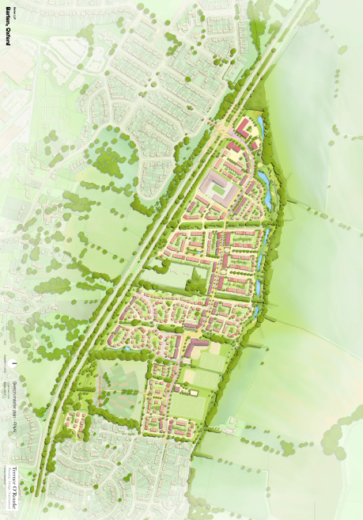

Appendix 6

Parameter Plan 1

Building Zone

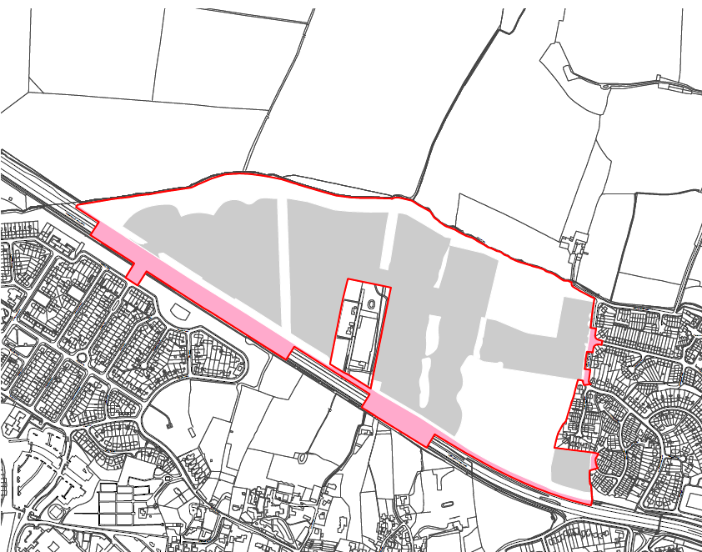

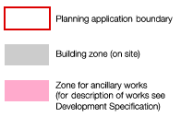

Appendix 7

Parameter Plan 2

Land Use

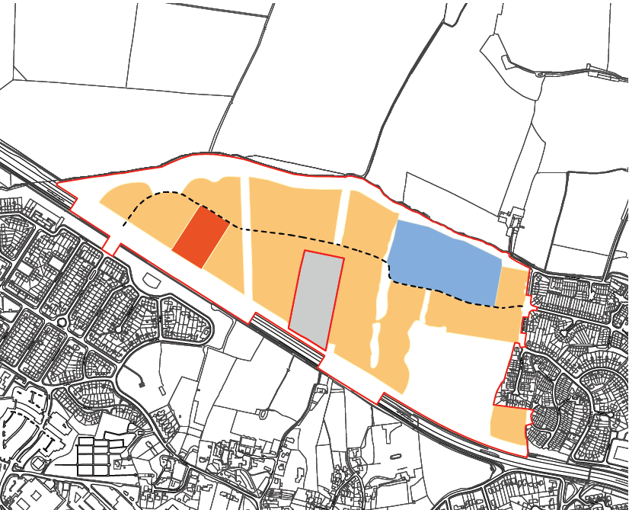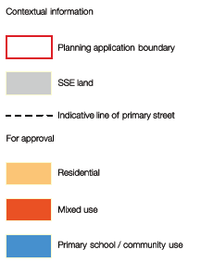

Appendix 8

Parameter Plan 3

Open Space and Landscape

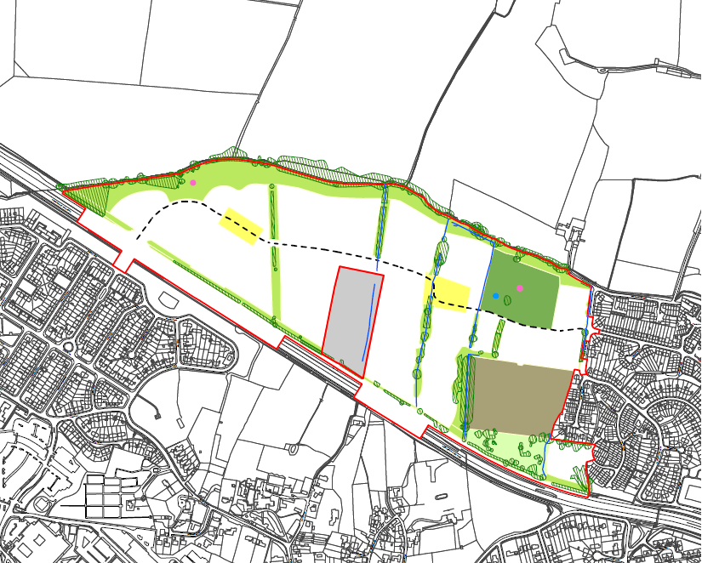

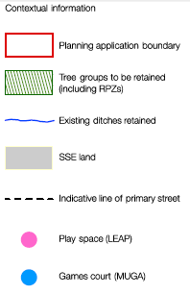 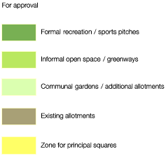

Appendix 9

Parameter Plan 4

Movement and Access

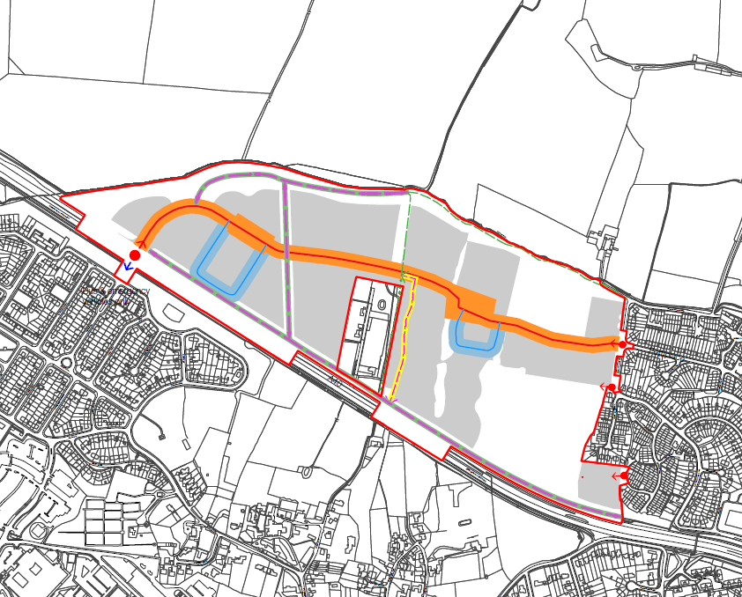

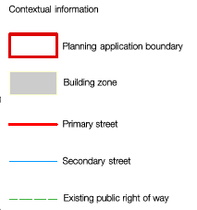 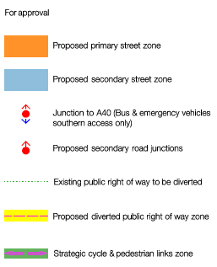

Appendix 10

Parameter Plan 5

Density

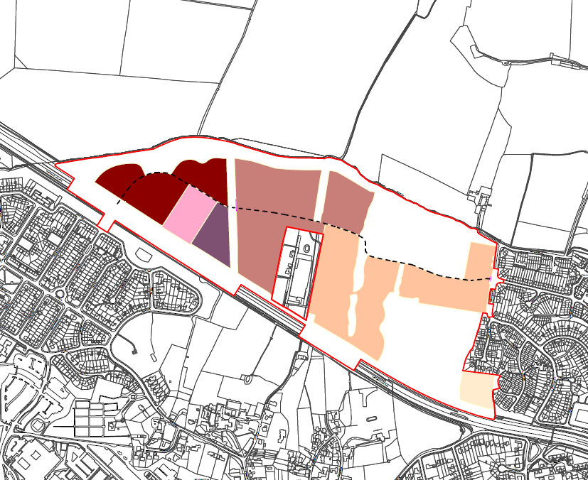

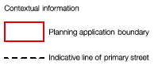 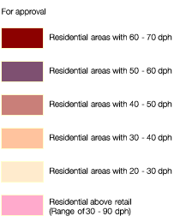

Appendix 11

Parameter Plan 6

Building Heights

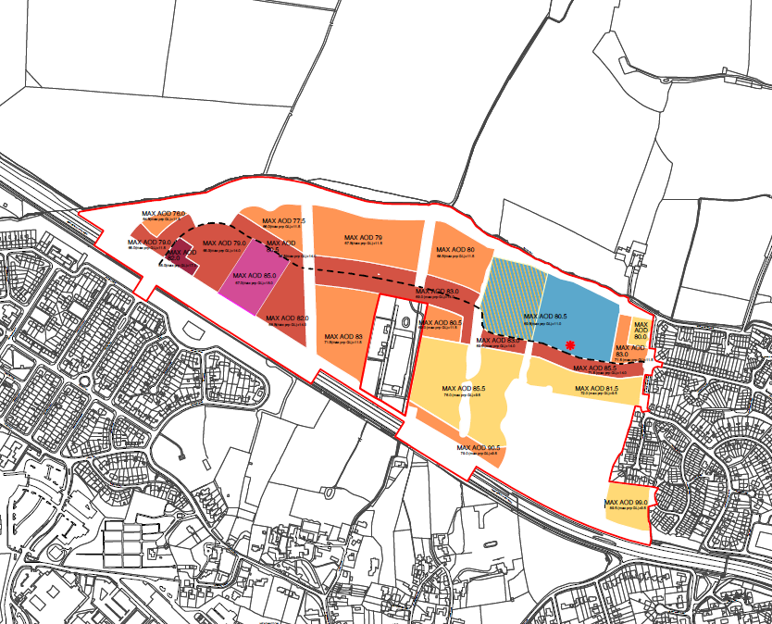

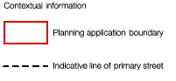

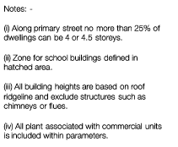 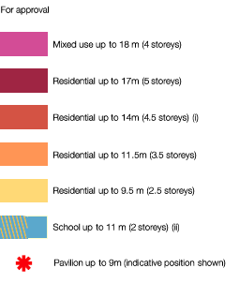

Appendix 12

Summary of Compliance with the Design Code

